Project Report

Title of Project: Smart Travel Companion
Name of the Innovator: Jahnavi G
Start Date: 01-09-2025
End Date: 04-09-2025

Day 1: Empathise & Define
Step 1: Understanding the Need

• Which problem am I trying to solve?
• My web application solves the problem of trip planning being confusing and time-consuming, where users find it difficult to create a proper itinerary, manage their budget, and choose places based on their interests. It provides a simple platform to enter travel details and quickly get a structured travel plan and recommendations in one place.

Step 2: What is the problem?
The problem is that planning a trip is often difficult and time-consuming because people struggle to decide where to go, what to do each day, and how to manage the trip within their budget. Most users end up using multiple sources like blogs and apps, which makes planning confusing and unorganized.

Why is this problem important to solve?
This problem is important to solve because trip planning directly impacts the travel experience. When planning is unorganized, people often waste time searching different websites, get confused about what to do each day, and end up overspending. It can also lead to poor decisions like missing key attractions, choosing unsafe or inconvenient routes, and not managing time properly. A smart travel planner helps users save time, reduce stress, plan efficiently within budget, and enjoy a smoother and more confident trip.

Ask 2-3 people what they think about the project:
- Feedback from others:
- Person 1 (College Student Traveler): “This web app is really helpful because making a travel plan takes a lot of time. It gives a proper itinerary quickly and makes planning easier.”
- Person 4 (First-Time Tourist): “This is a great concept because I usually don’t know what places to visit. The app gives clear recommendations which saves effort.”
- Person 5 (Working Professional): “It’s practical and user-friendly. If it can save and export plans, it becomes a complete travel assistant for busy people.”
AI Tools Used for Step 1 and Step 2
AI tools used:
- ChatGPT (OpenAI)
  - Used to power the AI travel assistant’s conversation system, allowing it to understand user questions and give personalized responses.
  - Helps generate travel recommendations, itineraries, and destination insights.
  - Also supports FAQ handling and provides real-time travel advice in a natural, chat-based format.
- Google Maps API (Location Intelligence)
  - Used for location tracking, showing nearby attractions, restaurants, and hotels.
  - Provides real-time route suggestions and travel time estimates.
- IBM Watson Assistant (Reference for Design)
  - Used as a reference model for building structured conversations and personalized travel guidance.
  - Helps in understanding intent detection and creating logical chatbot flows.
- Google Dialogflow (Reference for AI Chat Flow)
  - Studied for intent recognition, context handling, and managing multi-turn conversations with users.
- Meta MGX / AI Web App Builder (No-Code Platform)
• Used to build the Smart Travel Companion web application interface with AI-assisted components and workflows.
Day 2: Ideate
Step 3: Brainstorming solutions
While exploring ways to solve the challenges of travel planning and management, I came up with a few possible solutions — some practical, some creative:
- AI-Powered Travel Assistant Web App – An intelligent web application that helps users plan trips, generate itineraries, and get travel suggestions based on their inputs.
- Smart Itinerary Generator – A feature that automatically creates a day-wise travel schedule depending on destination, trip duration, and user preferences.
- Personalized Travel Recommendation System – A module that suggests places to visit, activities to try, and food options to explore for a better travel experience.
- Travel Budget Planner – A planning tool that helps users estimate and manage travel expenses by splitting the budget into categories like stay, food, transport, and activities.
- Trip Organizer Dashboard – A single place where users can view their full travel plan clearly, making trip planning more organized and easier to follow.
Step 4: My favourite solution:
My favourite solution was building the AI-Powered Travel Assistant Web Application (Smart Travel Companion) because it combines multiple travel planning needs into one platform. It helps users quickly generate a day-wise itinerary, get useful travel suggestions, and organize trip details easily, which saves time and makes trip planning simpler and more efficient.
Step 5: Why am I choosing this solution?
I am choosing this solution because it is the most practical and useful option for real users, as it saves time and reduces the stress of planning a trip. Instead of searching different websites for itinerary ideas, budgets, and travel tips, the Smart Travel Companion provides everything in one place with organized recommendations. It also improves the overall travel experience by helping users plan better, manage expenses, and make confident travel decisions.
AI Tools you can use for Step 3-5:
AI Tools for Step 3–5
- ChatGPT (OpenAI)
  - To design conversation flows, generate personalized travel recommendations, and refine the AI assistant’s responses.
  - Helps create FAQs, itineraries, and travel tips for different types of users.
- Meta MGX
  - For building and testing the interactive app interface without coding.
  - Enables integration of features like itinerary management, location suggestions, and user profiles.
- Google Maps API
  - To provide location-based data, nearby attractions, routes, and travel time estimates.
  - Helps make the AI assistant’s recommendations accurate and practical.
- IBM Watson Assistant / Google Dialogflow (Reference Tools)
  - For designing structured conversations, intent detection, and handling multi-step travel queries.
- Canva Magic Write / Notion AI (Optional)
  - For documenting ideas, creating presentation visuals, and summarizing solutions for reports.

AI Tools you can use for the take-home task:
We use ChatGPT for ideas and content, Meta MGX to build the app prototype, Google Maps API for travel data, and Canva/Notion AI for visuals. We also reference Dialogflow/IBM Watson for chatbot design.
Day 3: Prototype & Test
Step 6: Prototype – Building my first version
What will my solution look like?
- Mobile app with clean, user-friendly interface – Easy to navigate for all types of travelers. o Chat-based AI assistant – Users can ask questions and get instant travel recommendations.
- Personalized itineraries – The app creates schedules based on user preferences, time, and budget. o Real-time suggestions – Provides up-to-date recommendations for hotels, attractions, and routes.
- Interactive maps and trip planner dashboard – Helps users visualize their travel plans and navigate easily. o Quick access buttons – Fast links for bookings, travel tips, and FAQs to make planning efficient.
Design Style:
- Minimalist & Clean: Easy-to-navigate layout o Modern & Friendly: Rounded buttons and soft colors Interactive & Visual: Maps, icons, and dashboards o Consistent Theme: Unified colors and fonts
Prototype tools:
- Meta MGX & Figma: Build and design app interface and workflows.
- Canva & Google Maps API: Create visuals and integrate maps for travel planning.
What AI tools will I need to build this?
AI Tools Needed to Build the Smart Travel Companion
❖ ChatGPT (OpenAI):
    - Powers the AI assistant to answer travel questions and give recommendations.
    - Creates personalized itineraries based on user preferences and inputs.
❖ Meta MGX:
    - Builds the app interface and interactive workflows without coding. o Integrates AI features like chatbot responses and trip planning modules. ❖ Google Maps API:
    - Provides real-time location data and nearby attractions.
    - Offers routes, travel times, and navigation for user itineraries.
❖ IBM Watson Assistant / Dialogflow:
    - Designs structured chatbot conversations and manages multi-step queries.
    - Detects user intent and ensures accurate AI responses.
❖ Canva / Notion AI:
    - Creates visuals, diagrams, and presentation slides.
    - Helps document workflows, ideas, and AI implementation steps

What AI tools I finally selected to build this solution?
- Chat GPT
- Metamgx
- Google Maps API

< Build The Innovation>
<DASHBOAD OF THE TOOL>

Tool Link: smart travel companion


Internal Working of tool:
Smart Travel Companion: Page Overview

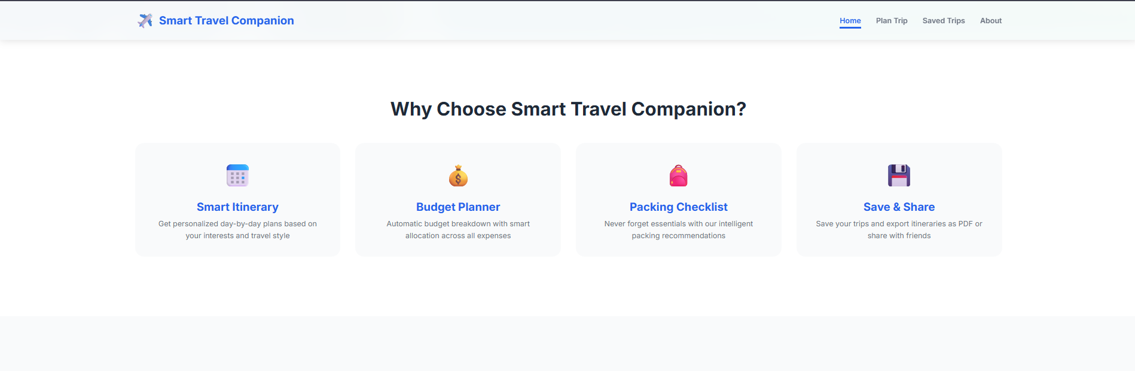

Planning section overview:

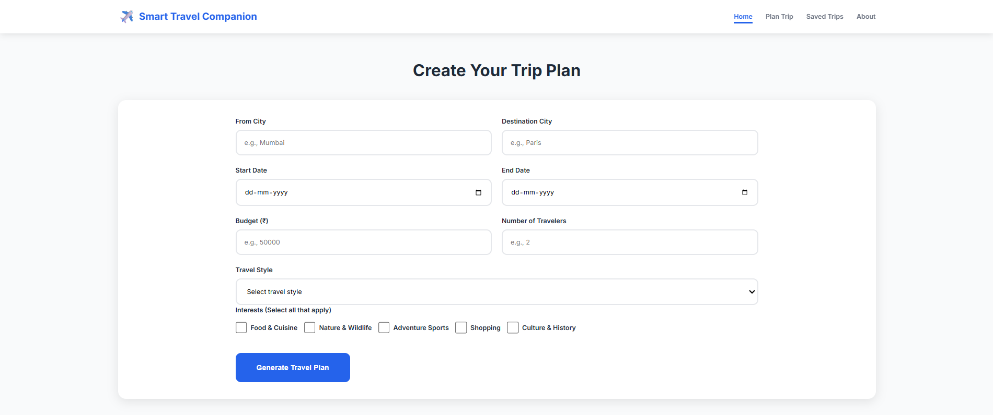

Working of planning trip:

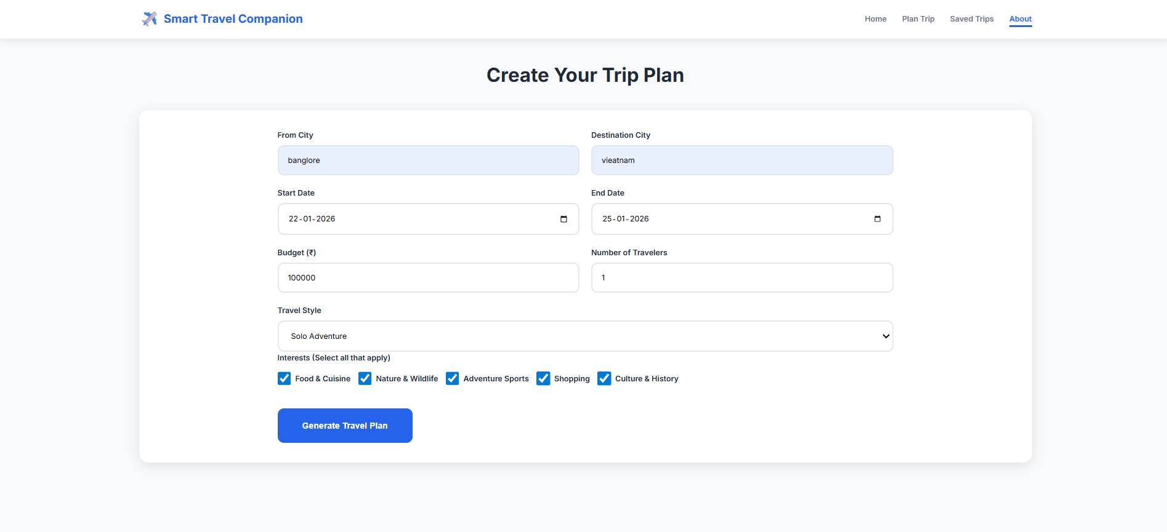

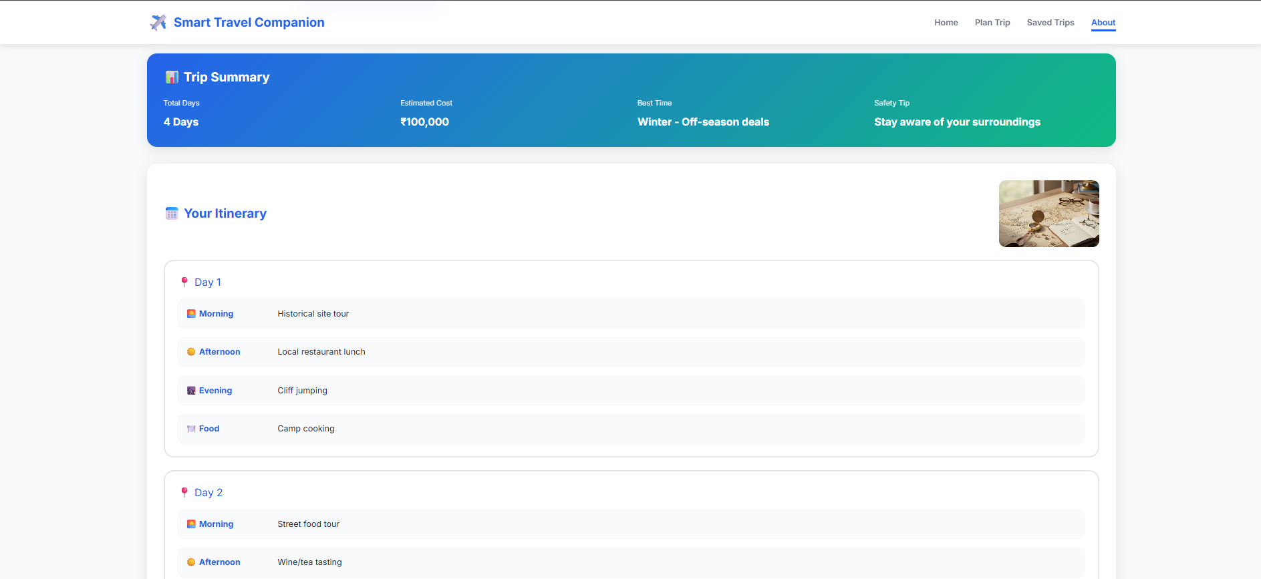
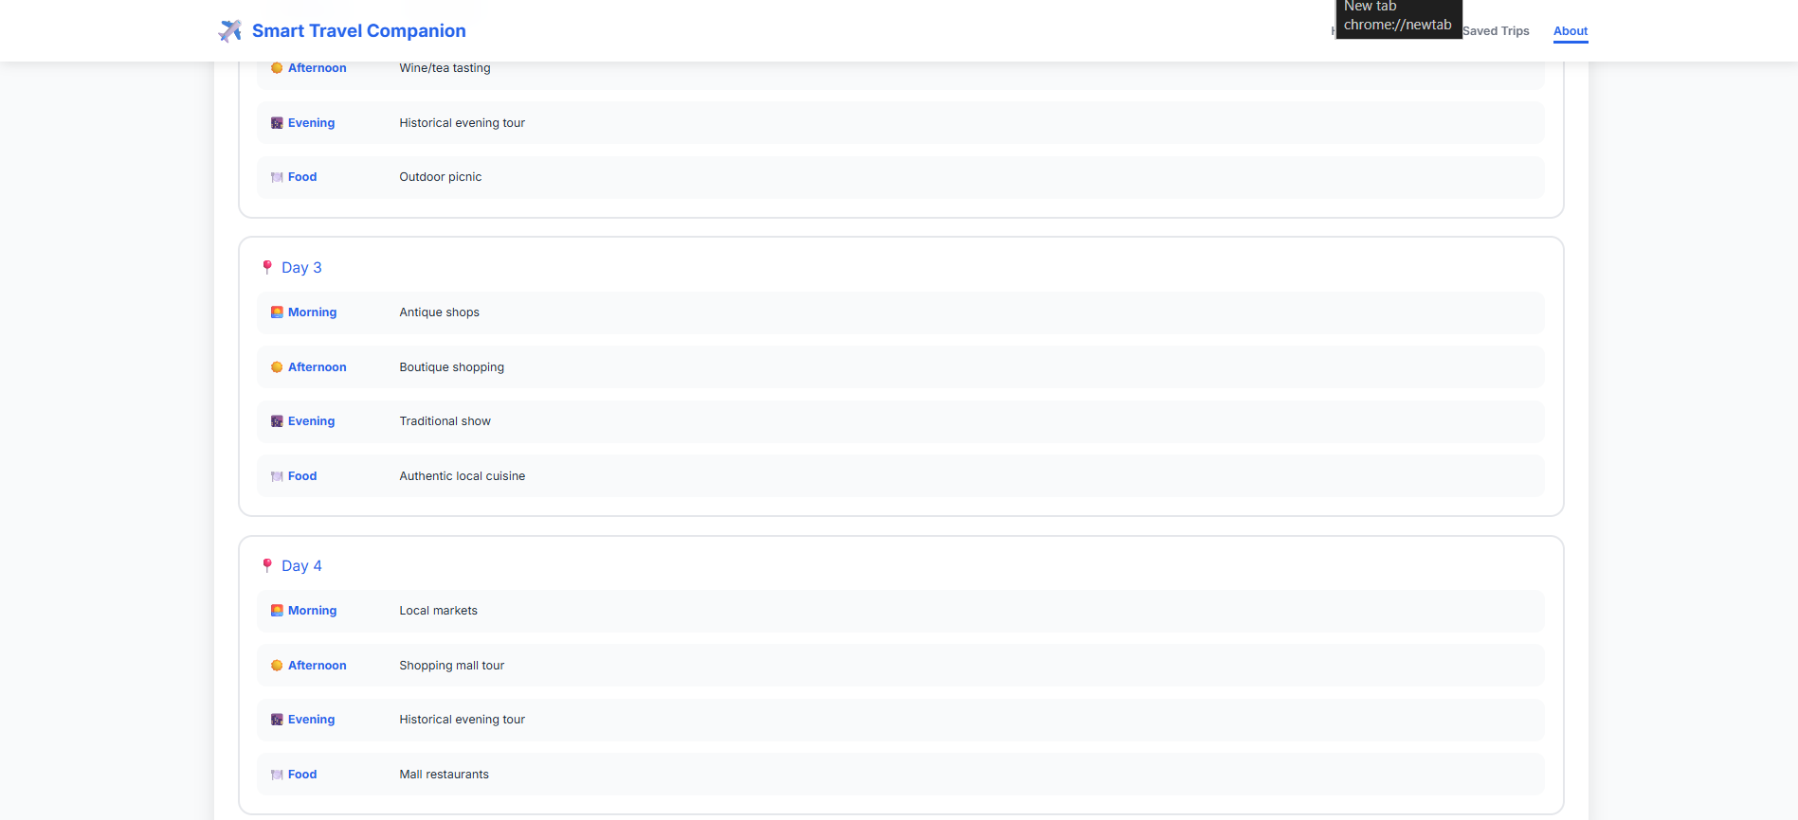
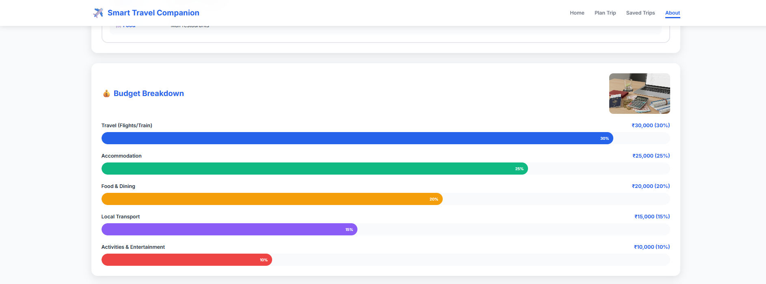

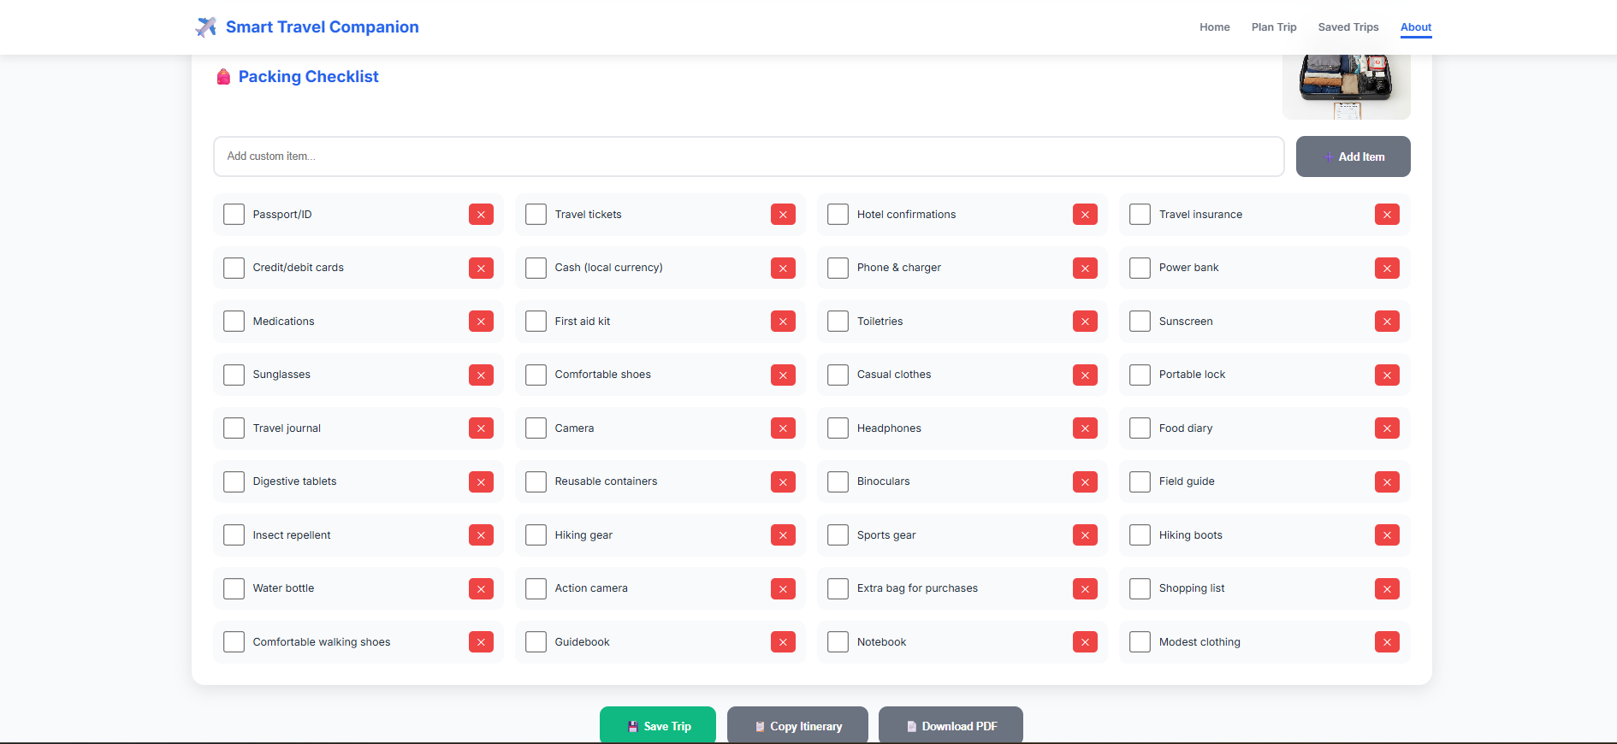

Saved trips section overview:


About section overview:

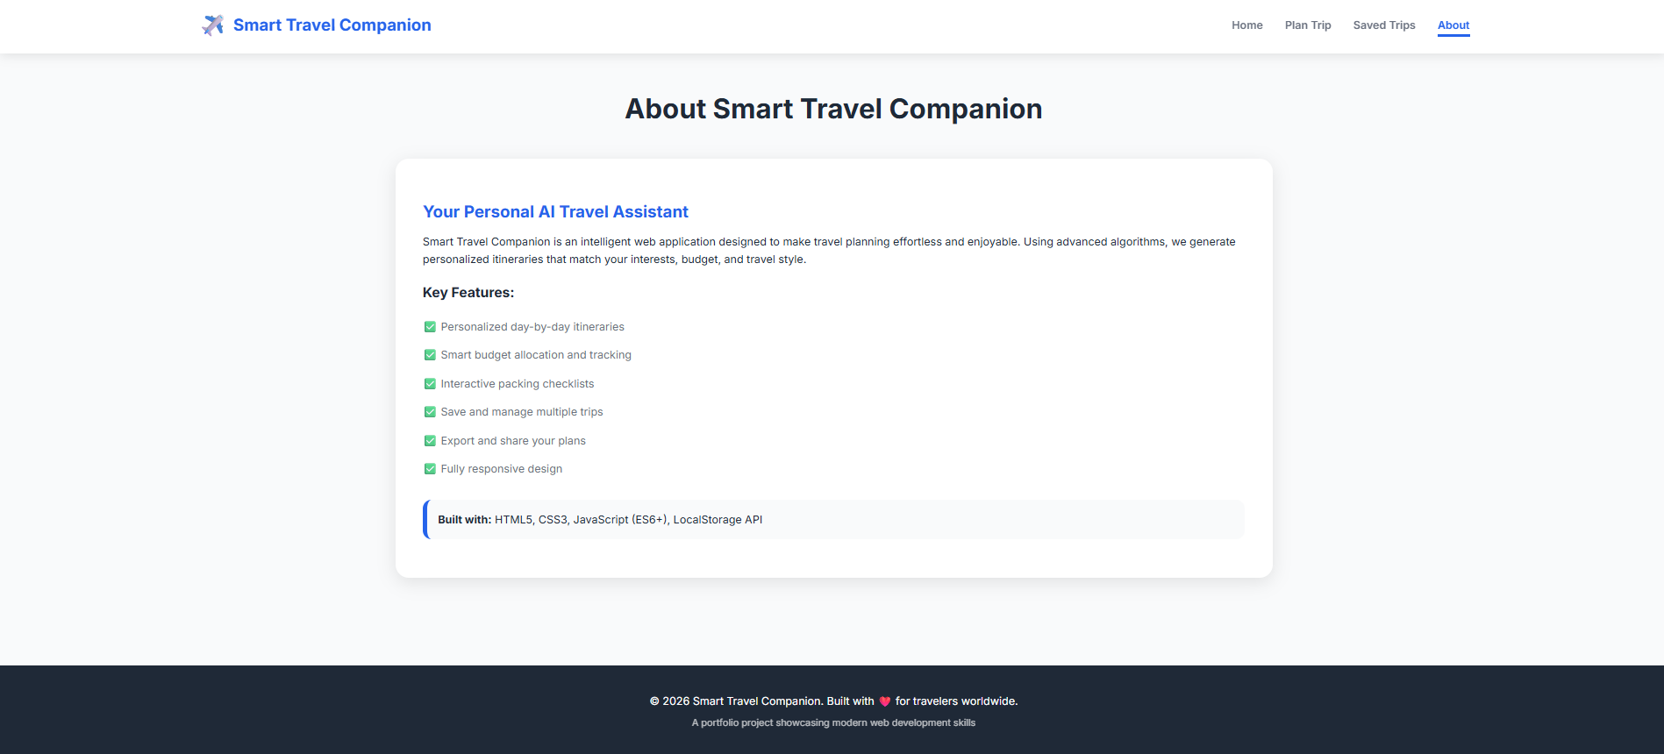

Step 7: Test – Getting Feedback
• Who did I share my solution with?
I shared my Smart Travel Companion solution with:
- I shared my Smart Travel Companion prototype with friends and classmates who frequently travel.
- I also showed it to family members and teachers/mentors to get diverse perspectives.
- Additionally, I asked experienced travelers for their opinions on usability and features.
- I collected feedback from online travel communities to understand broader user expectations.

What feedback did I receive?
Feedback: Pros and Cons
Pros
- Saves time with fast trip planning
- Personalized itineraries and recommendations
- Real-time suggestions for attractions and routes

Cons
- Requires internet for full functionality
- Limited offline access
- Privacy concerns with location and travel data

My Response for The Feedback:
After receiving feedback, I improved the app interface for easier navigation and enhanced personalization for better itineraries. I added offline features for maps and essential travel info, and addressed privacy by anonymizing user data and adding clear consent options. I also optimized realtime recommendations and plan to include features like budget tracking and multi-trip management in future updates to make the app more comprehensive and user-friendly.

What works well:
What works well:

- The web app is simple and easy to use, with a clear flow from input to output.
- It quickly generates a structured travel plan, saving time for the user.
- The itinerary is displayed in an organized format, making it easy to understand.
- The interface looks clean and works smoothly on both mobile and desktop.
- It provides useful travel suggestions that improve the trip planning experience.

What needs improvement:
What needs improvement:
- The app can include more detailed customization, like travel style (solo/family) and specific interests.
- Adding a Save Trip feature would help users store and revisit their itineraries later.
- The itinerary can be improved by showing maps/nearby places and better location-based suggestions.
- A budget split section (travel, stay, food, activities) would make planning more practical.
- Adding error handling and validation (missing inputs, invalid dates) would improve reliability.
- The app can be enhanced with export options like Download PDF / Copy itinerary for easy sharing.

AI Tools you can use for Step 6-7:
ChatGPT/Perplexity AI/Claude AI/Canva AI/Chatling AI/Figma AI/Metamgx/Gamma AI: You can use these tools to build solutions/models or mock-up dummy prototypes

Day 4: Showcase
Step 8: Presenting my Innovation: Presenting My Innovation
- Smart Travel Companion: AI-powered mobile app for seamless travel planning.
- Chat-Based AI Assistant: Answers questions, gives recommendations, and creates personalized itineraries.
- Interactive Maps & Real-Time Suggestions: Helps users find attractions, routes, and traditional cultures of the place
- User-Friendly Design: Simple navigation, clean interface, and quick access to features.
- Offline Access & Privacy: Key travel info available offline; user data is anonymized for safety.
- Convenience & Efficiency: Combines planning, bookings, and guidance in one platform.

Impact: The Smart Travel Companion saves time, personalizes itineraries, and makes travel planning easier, smarter, and more enjoyable.

<SHOWCASE YOUR INNOVATION TO YOUR PEERS>
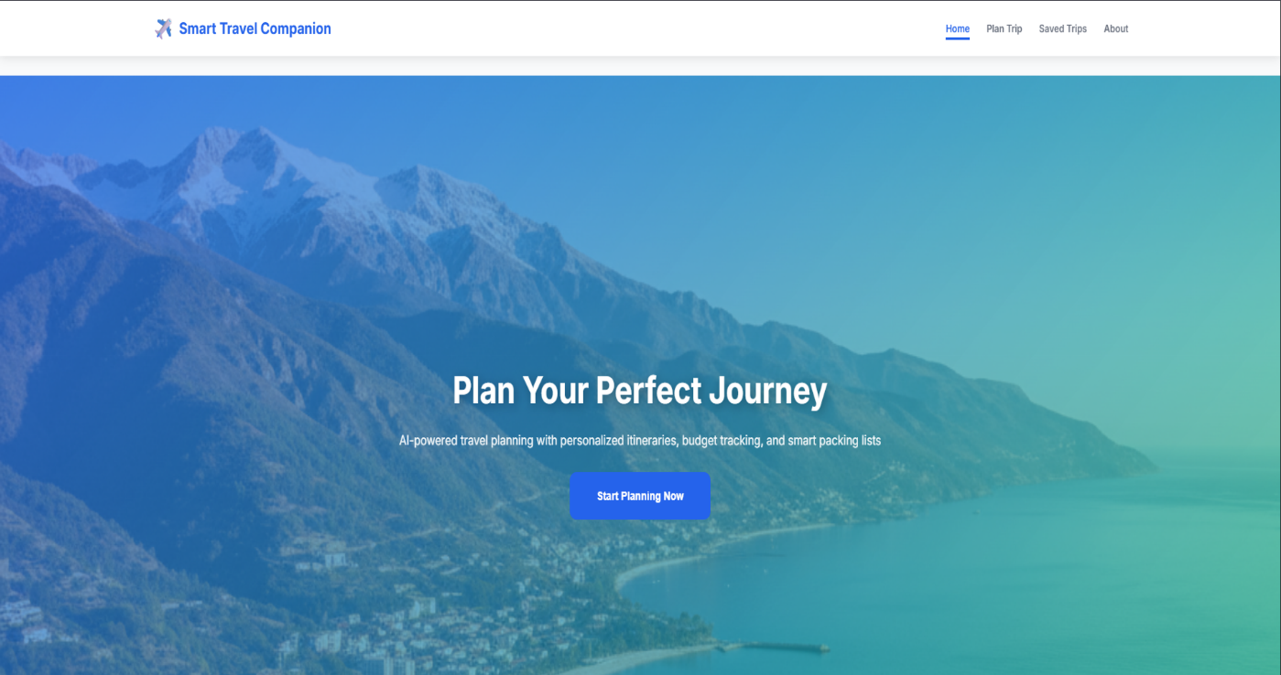

Step 9: Reflections
- What did I enjoy the most during this project-based learning activity?
I enjoyed bringing an idea to life the most during this project. It was exciting to design and build the Smart Travel Companion, explore AI tools, and see how my concept could solve real travel problems. I also loved testing the app and getting feedback, which helped me improve the solution and made the process very rewarding.

What was my biggest challenge during this project-based learning activity?
My biggest challenge was integrating AI tools effectively to create a functional and interactive travel assistant. It was sometimes difficult to ensure accurate responses, personalized recommendations, and smooth conversation flow within the app. Additionally, balancing user-friendly design with complex AI functionality required careful planning and testing.

Take-home task
JahnaviG12/-Smart-Travel-Companion_Project-Report
AI Tools you can use for Step 8:
Canva AI: You can use this to design your pitch document. Download your pitch document as a PDF file and upload on GitHub

